Dillon Dugan

**Mystery at the Wildlife Preserve: Multispectral Imagery**

A post-doctorate student, Mitch Vogel, at the Mistford College has been doing research on ornithology of a local nature preserve. From his observations, there appears to be a decline in the number of nesting pairs of Rose-Crested Blue Pipets. Noticing this decrease could significantly affect Pipet population, the Pangera Ornithology Conservation Society decides to sponsor Mitch to identify the possible reason for this phenomenon with additional resources and datasets for analyzation. Among the given research material is satellite observations from the National Space Service of the wildlife preserve. Mitch would like to have some visual analytics done to help determine a possible cause of the nesting pair decline. The task of multispectral imagery of the satellite data may provide insight on the nesting pairs problem. The data was provided with tif and ascii files however as both contain the same information, only one is necessary for the analysis. I decided to work with tif imagery to work with gdal packages and cleanly separate each band for multi-imagery analysis. Use of the cv2 package and matplotlib also helped with visual analysis and displaying/saving images. The cv2 package was also useful for converting color schemes as the images needed to be changed to correct RGB format or to HSV for image masking. Overall, the data is well structured and mostly complete, there was some NaN values that were converted using numpy nan_to_num.

The National Space Service provided satellite data of the wildlife preserve over 2014 to 2016. These images are not evenly spaced in time but provides information for each season for every year resulting in 12 images. These images were provided as 8-bit tif and ascii files where each observation is one pixel of the image with x=0, y=0 referring to the first pixel in the upper left corner to bottom right at x=650,y=650. Each observation has 6 channels referring to the observed blue, green, red, near-infrared, shortwave infrared 1 and 2 wavelengths. Using these channels, imagery can be created to analyze the area by combining certain bands. This data are actual wavelength measurements rather than pictures of the wildlife so for visual analytics, these values will need to be displayed to be viewed and won’t demonstrate what the wildlife looks like but can still be analyzed visually to determine area that could be contributing to the nesting pairs decline. The first band refers to blue wavelengths from 450 to 520 nanometers, which are useful for imagery where water needs to be penetrated, display thin clouds and brightness of visible light. The second band is for green wavelengths from 520 to 600 nanometers, helpful to display different plant types and brightness of visible light. The third band is red wavelengths at 630 to 690 nanometers, which gives insight on vegetation color and mineral deposits on bare lands. The next three bands are the infrared channels, which provides information about wavelengths that are beyond visible wavelengths. Near Infrared (NIR) starts at 770 to 900 nanometers which is partially absorbed by water and is highly sensitive to vegetation structure and chlorophyll. Short-wave Infrared (SWIR) 1 spans from 1550 to 1750 nanometers and is completely absorbed by water and highlights moisture of soil and vegetation. It is also able to penetrate thin clouds to provide information on cloud days. Short-wave Infrared (SWIR) 2 from 2090 to 2350 nanometers are only useful for differences in soil minerals, it is unaffected by vegetation. All this information will help assess health of the ecosystem and provide imagery of the preserve to be analyzed for potential problems or investigate some sort of change in the ecosystem over time.

Overall, three goals of the visual analysis were provided. The first goal is to determine the scale and orientation of the satellite data, the next is to identify features easily defined with a high level of confidence, and the last being the research task of finding imagery features that aren’t easily explained and might be the cause of the declination of nesting pairs of Pipets at the wildlife preserve. These goals can help Mitch with his research task at hand. For the first goal, Boonsong Lake on the preserve is provided with the given information that its image orientation is north to south and it is 3000 feet long (Figure 1). To solve this goal, Boonsong Lake must be identified on the satellite data then it must be determined how many pixels long it is. Once that’s obtained, the feet to pixel ratio can be calculated by dividing 3000 feet by the length of the lake in pixels. Then square than ratio to get square feet per pixel. For the second goal, the first three bands can provide true color imagery of the preserve while the last three can give infrared insight that might not be visible to the human eye normally but can provide context to features that can be explained. For the last goal, different combinations of the bands can give indications of the plant health, flood/burned lands, snow/ice/cloud imagery, and Normalized Difference Vegetation Index (NDVI), or the comparison of bare ground to vegetation in an area. The true color and infrared imagery can also identify some unknown features, the other combinations can highlight important ones or demonstrate there is an issue that needs additional research.

Looking at the true color (RGB) imagery of the satellite data, I believe Boonsong Lake can be seen between the pixels x = 120, y = 450 and x = 200, y = 520 (Figure 2). Looking at the given image of the lake and the clipped satellite preview of the lake, it seems the orientation is the same meaning the satellite imagery is giving in normal cardinal directions with north facing the top row and south at the bottom. From a visual measurement, it seems the lake might cover 30 pixels, however, using the cv2 and matplotlib packages, the lake can be masked and measured to ensure the length. First the image needs to be converted to HSV (Hue, Saturation, Value) to set up the image for color masking (Figure 3). Then a blue mask can be fitted with a lower band and upper band to obtain the range of pixels that identify just the lake (Figure 4). I found the bounds by directly getting the values from the pixels of the lake in an image editing application. Then the lower and upper masks can be combined to get a full mask of the lake. Once the lake has been isolated, a contour can be applied to the image to get a rectangle outline around the object and measure the pixel dimensions of that rectangle (Figure 5). Then as stated before, the actual length of 3000 feet can be divided by the pixel length to get a feet per pixel, squaring that ratio gives square feet per pixel. After all the masking and contouring was done, I found that the lake does have a length of 30 pixels from the north point to the south point. This gives a ratio of 100 feet per pixel or an area ratio of 10,000 square feet per pixel. The satellite data gives 651 by 651 rows therefore 651 by 651 pixels, or 423,801 total pixels. The entire imagery of the preserve then covers 4,238,010,000 square feet or about 97,300 acres. This will be important when doing observations of the imagery features as each pixel is going to cover about a quarter of an acre.

Using a for loop, the true color and infrared imagery can be viewed for all tif files provided. Throughout all the images (displayed as True color and IR imagery for Goal 2 below), there is a clear indication of certain features such as the vegetation versus bodies of water and bare ground/man-made structures. Multiple of the lakes and river systems can be seen and highlighted by infrared data. There is some form of a man-made structure running north to south through the middle of the imagery, possible road or power line, there are a few trails that pop up though they are harder to perceive at such a large scale. Based on visitor information, there’s quite a few hiking/cycling trails around the preserve. Clouds overhead and the shadows they cast can also be seen quite clearly. During the months of November for 2014 and 2015, the color image demonstrates a large amount of smoke and particulates in the air while the infrared highlights some of the active burns. Through all the images, there is an obvious change of seasons as vegetation color changes and water freezes especially when comparing to the winter months. Some of the topography can also be since with the infrared imagery, nothing very specific but difference between lower areas compared to hill tops. It can also be observed some sensor artifact on the right side of some of the images. Since this feature isn’t constant between all the images, appearing in some but not other as well as not being the same length/size in the ones it does show up in, it can be assumed these are errors in the sensors from the satellite and not any sort of imagery feature.

Similar to the second goal, the third goal could be worked using similar code, however, using false color band combinations for the important information that might not be visible by normal RGB imagery. For this, the plant health, Flood/burned land, Snow/ice/cloud, and NDVI bands were used. To obtain the plant health layer, the fourth, third, and second band were combined. This gives an insight of the near infrared sensitivity to plant structure and chlorophylls while getting a visual assessment of the vegetation color and abundancy. The Flood or newly burned land was obtained from the fifth, fourth, and second band, as the Short-Wave IR 1 data demonstrated moisture content of the soils and vegetation with a bit of overlap with the absorption of near IR waves by water as well as the imagery of possibly burned lands (lack of vegetation) from the green wavelengths and the near IR which highlights vegetation structure and chlorophyll content. The Snow/Ice/Cloud layer has the first, fifth, and sixth bands combined as each of those gives relative information about water, moisture, and soil content while ignoring vegetation color and abundancy which is not necessary for water analysis. The Normalized Difference Vegetation Index (NDVI) can be calculated by taking the difference of the fourth and third band divided by the sum of the fourth and third band. The NDVI can distinguish healthy vegetation from bare ground. All these combinations were applied for every satellite data provided as with was done with the second goal with a for loop. Overall, these imageries provided some additional help to identifying explainable features from goal 2, however, an area where infrared suddenly had an increase of some entity was also detected by the plant health. Working with a closer view of the infrared channels, plant health, and true color imagery for this area from x = 450, y = 300 to x = 550, y = 400 (displayed as True Color, IR, and Plant Health Imagery for Goal 3 below), there appears to be an appearance of so unknown substance that starts negatively affecting the ecosystem’s plant health starting around February 2015 and continuously growing downhill through September 2016. This could be a possible source of the decline in nesting pairs for Pipets. Remembering that the area per pixel ratio is about 10,000 square feet, by September 2016 nearly 3 acres of land have been affected by the unknown feature. The true color imagery also starts to demonstrate some discoloration around September 2016, otherwise barely detectable by RGB images. I would propose additional research of this area, as well as masking to search for other areas on the preserve that might by affected by the same problem, to determine if this is a source of the research problem.

With each goal completed, some visual analytics can be provided to Mitch that could help further his research into the Pipet issues. The scale being 10,000 square feet per pixels gives an estimate to the severity to certain areas of poor ecosystem health. With the imagery, we can estimate where the problems might be coming from as well as eliminate potentials hazards that can easily be explained by researchers, such as burned land from the November fires or cloud shadows causing false readings of vegetation health. Finally, a possible source of the problem was identified and can not easily be explained without additional information or research on the area. With that, hopefully the causation of the decline in nesting pairs can be explained and potentially fixed. There could also be some more analysis of other false color combinations to determine some potential features that need to be investigated further.

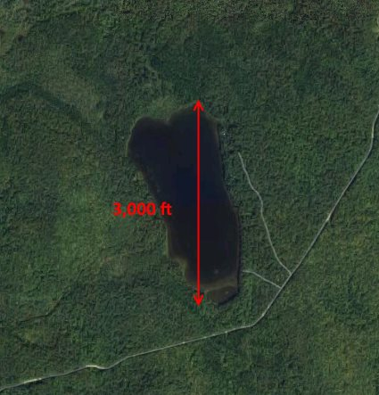 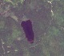

**Given Boonsong Lake image (Figure 1)** **Identified lake from satellite (Figure 2)**

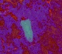 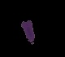

**HSV format of cropped lake (Figure 3)** **Blue mask of lake (Figure 4)**

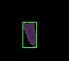

**Contour rectangle around lake (Figure 5)**

**True color and IR imagery for Goal 2**

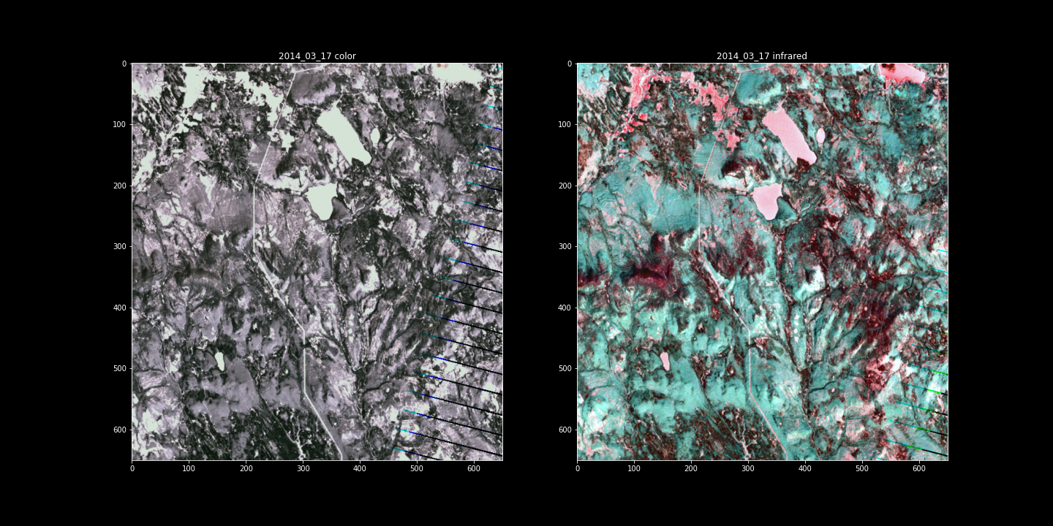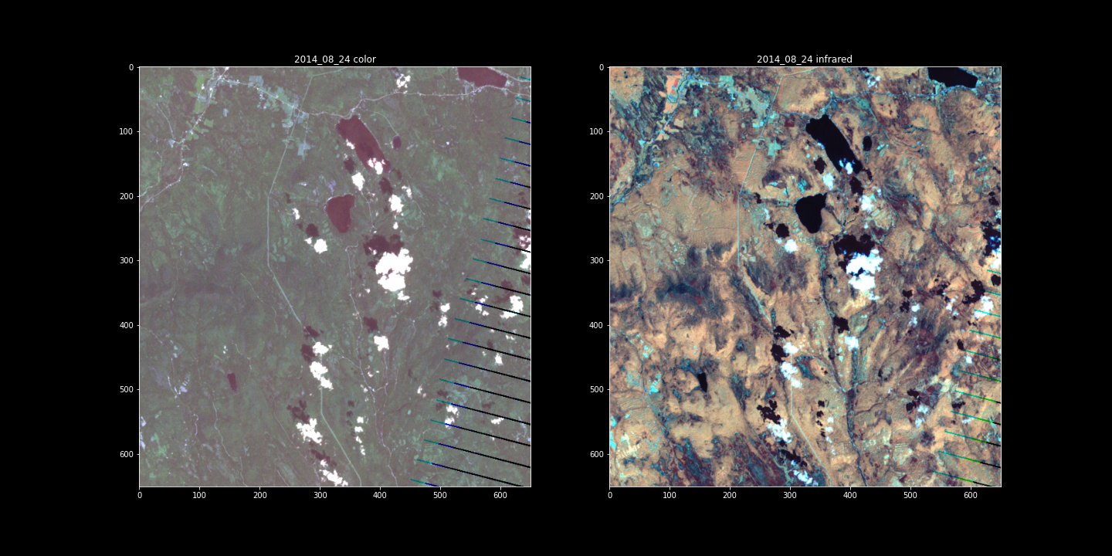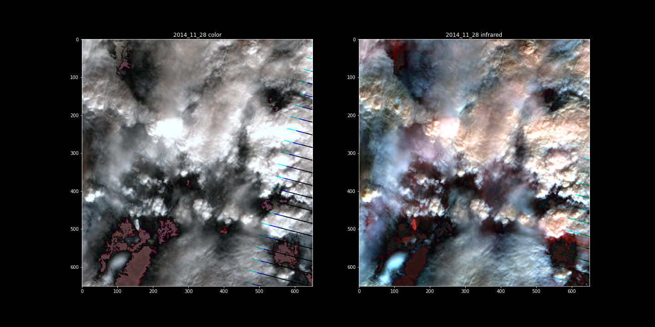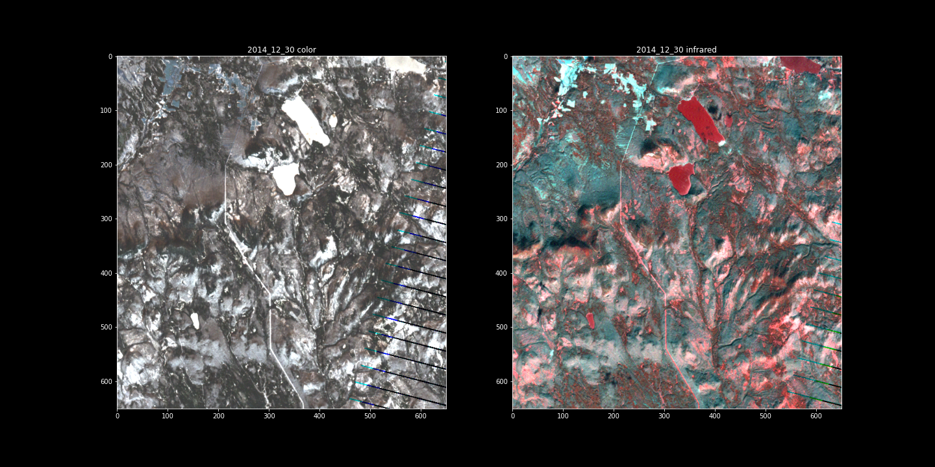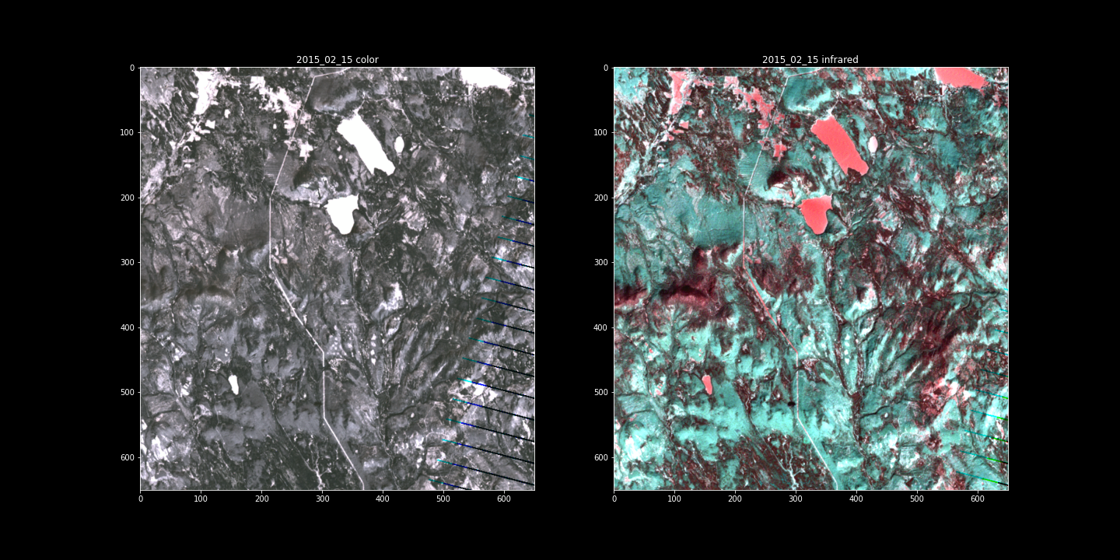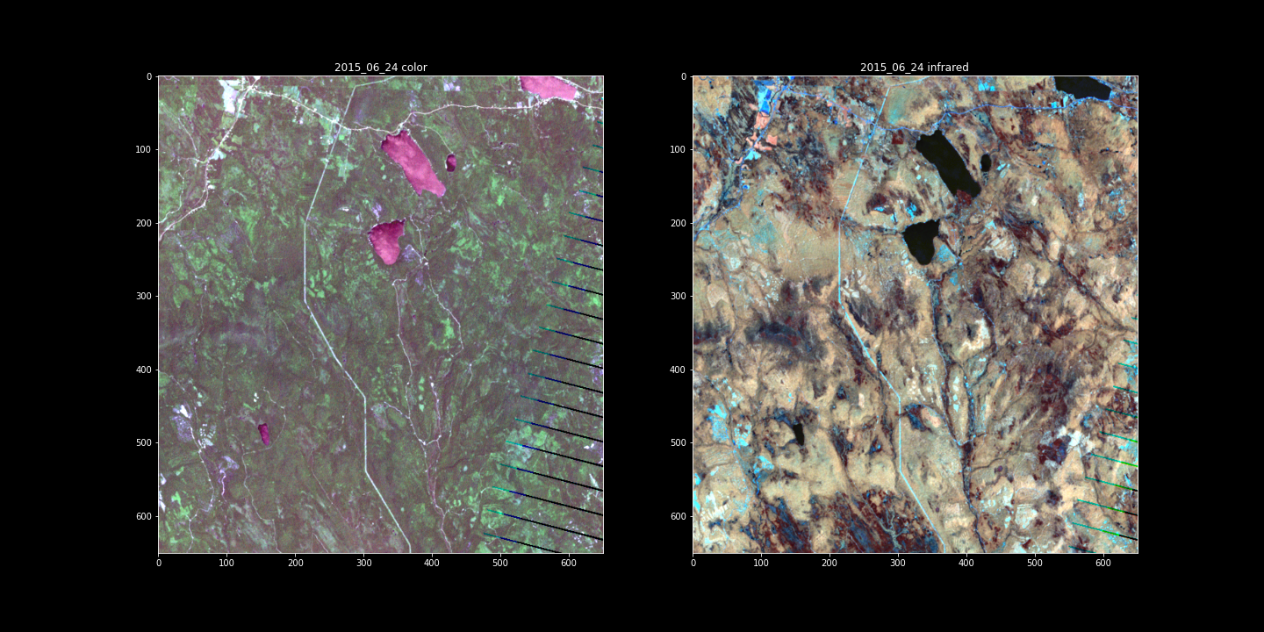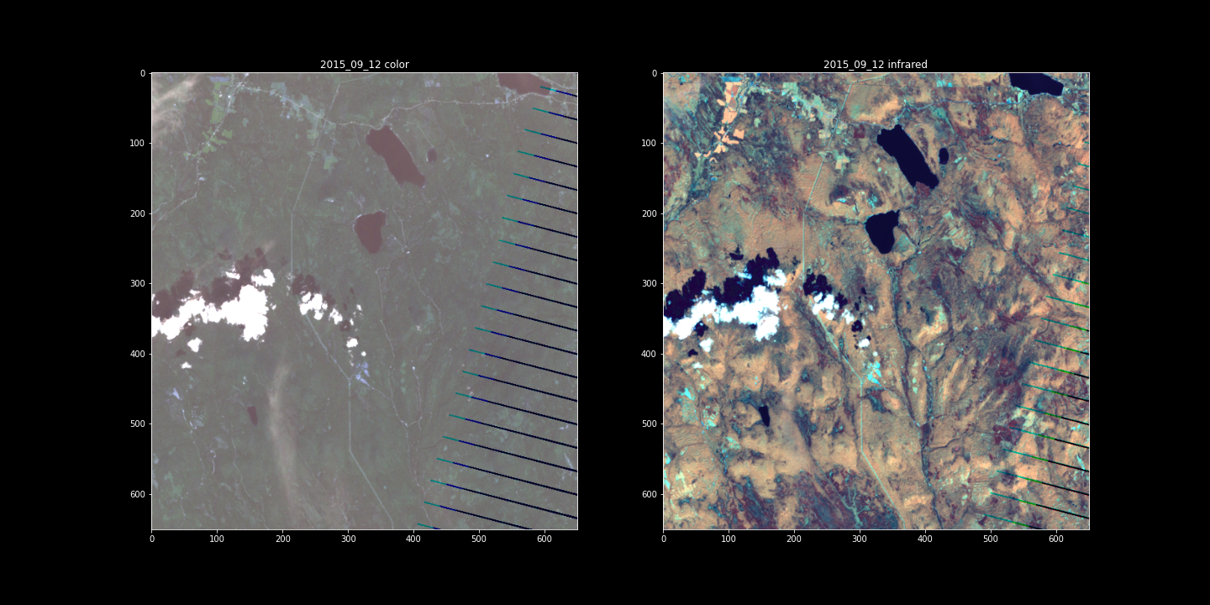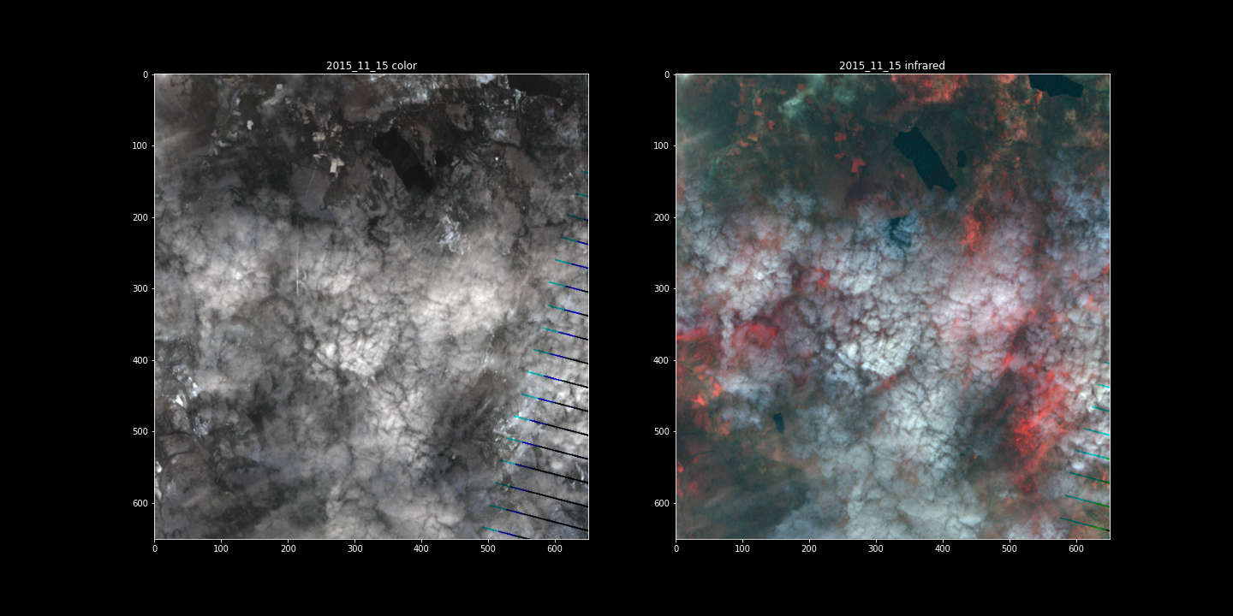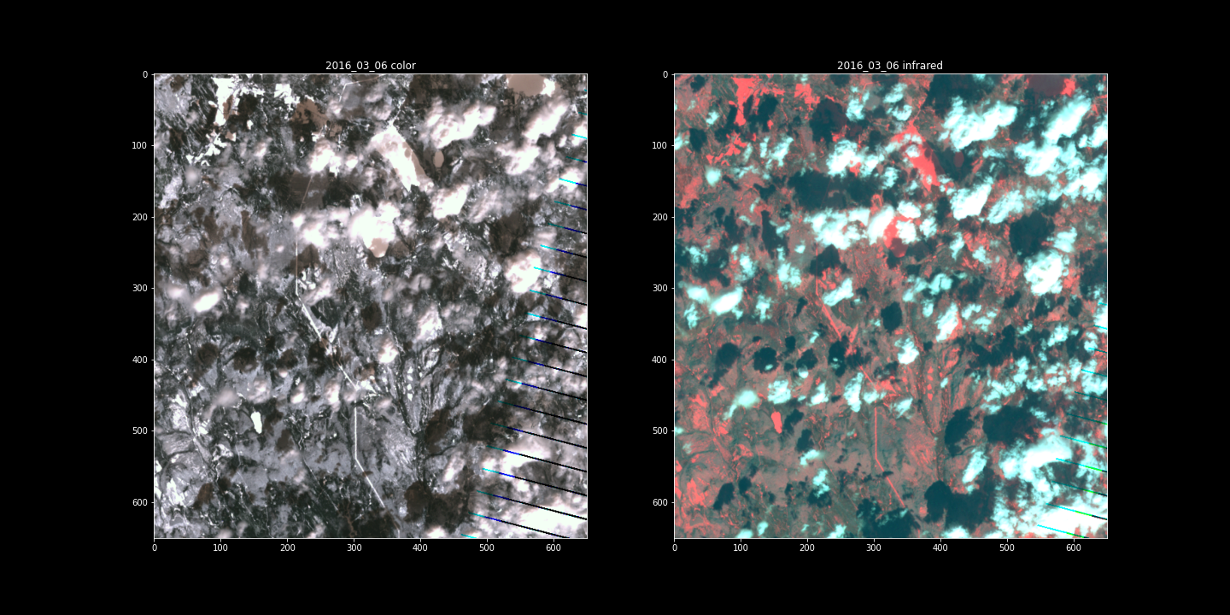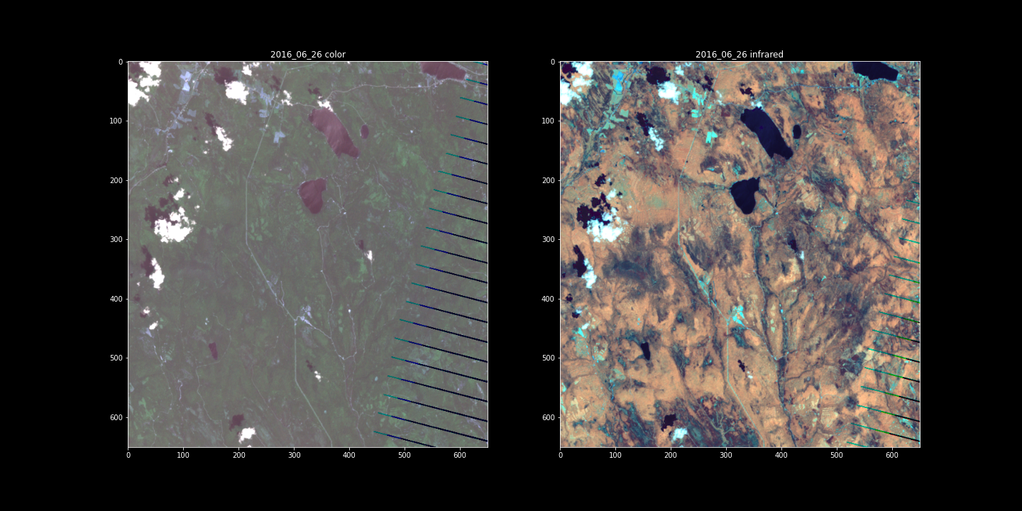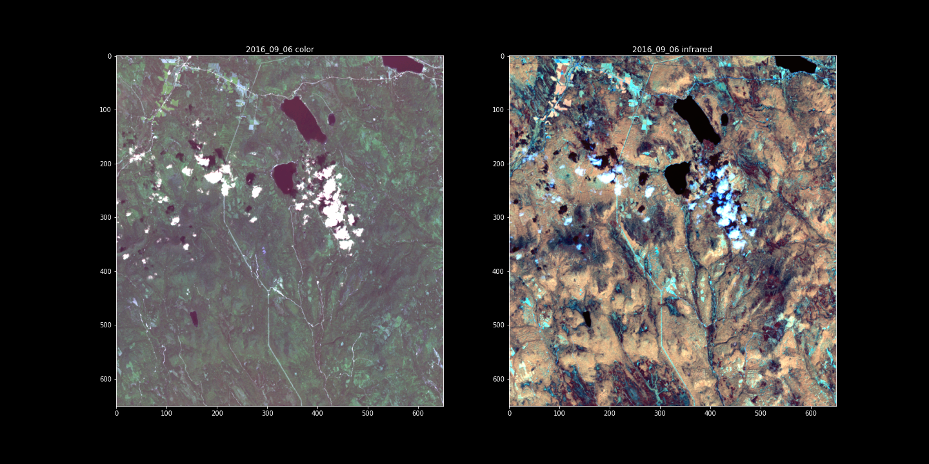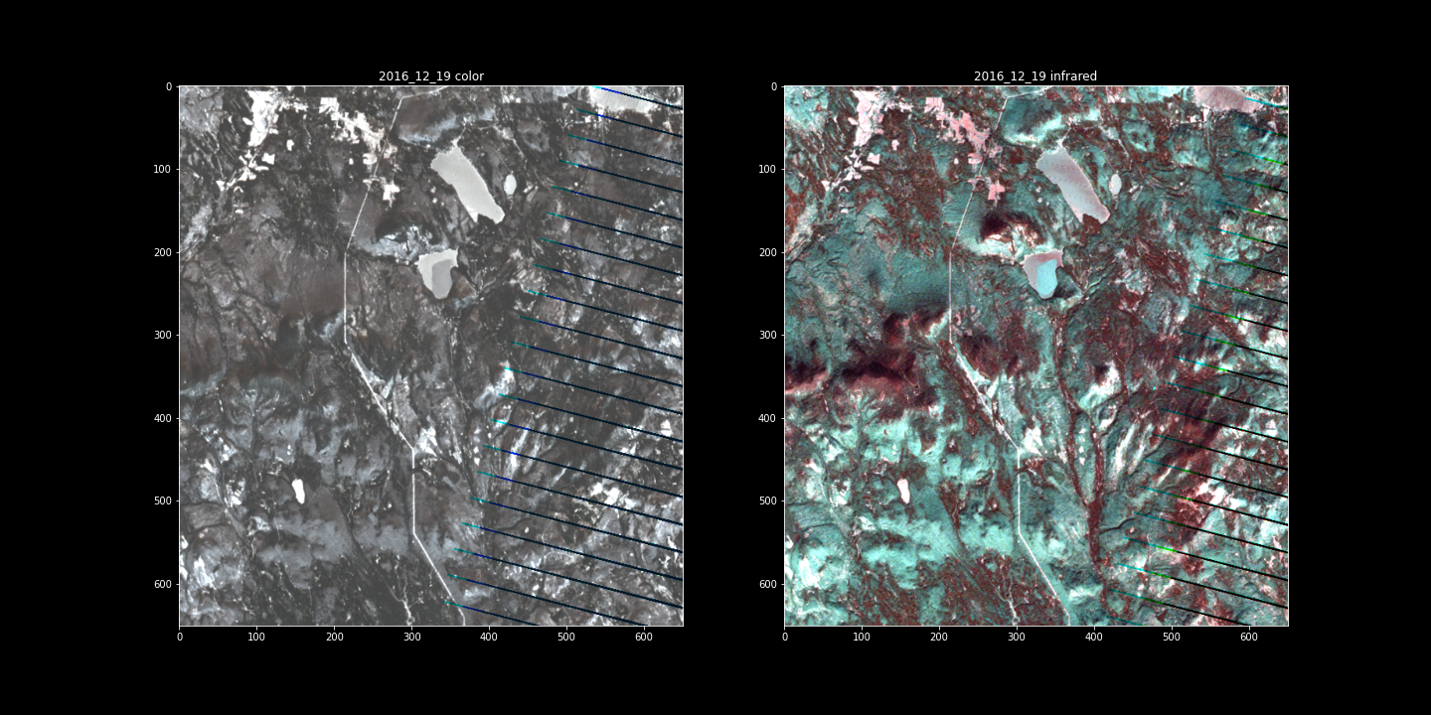

**True Color, IR, and Plant Health Imagery for Goal 3**